**Ketti R. Boller, D.D.S, M.S** 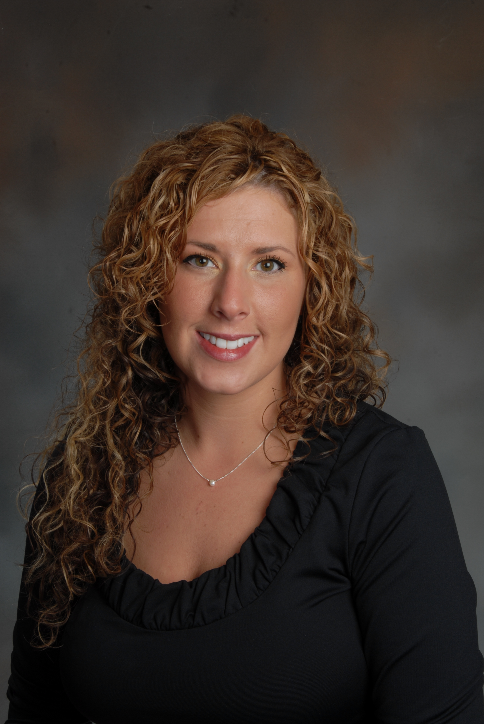

• Email: [kboller2@gmail.com](mailto:kboller2@gmail.com)

**Education:**

2010-2012 **University of Minnesota**

**Minneapolis, MN**

*Certificate in Orthodontics*

*Master of Science in Dentistry*

2006-2010 **Indiana University School of Dentistry**

**Indianapolis, IN**

*Doctor of Dental Surgery*

**Graduated with Highest Distinction** 2010

**Academy of Dental Materials Award** 2010

**American Academy of Oral and Maxillofacial Radiology Award** 2010

**Inductee of Omicron Kappa Upsilon Dental Alumni Members** 2010

**ADA Foundation Scholarship** 2007-2008

**Omicron Kappa Upsilon Academic Achievement Award** 2006

8/04-5/06 **Indiana University Northwest**

**Gary, IN**

*Bachelor of Art in Fine Arts*

*Minor in Biology*

*Minor in Art History*

8/02-8/04 **Indiana University**

**Bloomington, IN**

*Bachelor of Art in Fine Arts*

*Minor in Biology*

*Minor in Art History*

**Romy S. Chirila Memorial Scholarship** 2005

**Hoosier Dentist** 2003-2006

**Phi Eta Sigma (academic honor society)** 2002-present

**Alpha Lambda Delta (academic honor society)** 2002-present

**PPSC (pre-professional studies club)** 2004-2006

**Professional Licensure and Certifications:**

2012 **State of Illinois Dental License and Dental Specialist in Orthodontics,**

2012 **Board Eligible American Board of Orthodontics**

2011 **Certified: Invisalign**

2011 **SureSmile**

2011  **Laser applications in dentistry**

2010 **BLS**

**Professional Experience:**

8/12-Present **Get It Straight Orthodontics**

Associate Orthodontist

9/10-6/12 **University of Minnesota, Department of Orthodontics**

Teaching appointment, orthodontics-Third and Fourth year dental students

3/10 **IU School of Dentistry, Medical Missions**

**Honduras, Central America**

6/09-6/10 **IU School of Dentistry**

PBL Facilitator-Second year dental students

**Research:**

2010 – 2012 **University of Minnesota**  **Minneapolis, MN**

Master’s degree thesis: “Twisted Gastrulation and its Effects on Osteoclastogenesis”; under Kim Mansky, Ph.D., Department of Developmental and Surgical Sciences.

6/09-8/09 **Indiana University School of Dentistry Indianapolis, IN**

“The Effect of Systemic Fluoride Intake on Orthodontically Induced Root Resorption in DBA/2J.”; under Sean Shih-Yao Liu, D.D.S., Ph.D., Department of Orthodontics.

**Abstracts:**

Lan D. Pham, Kim C. Mansky, Ketti Boller, Eric D. Jensen, Aaron Broege, Ann E. Carlson, Michael O’Connor, Anna Petryk, and Rajaram Gopalakrishnan. **Disruption of BMP Signaling in Osteoclasts Regulates their Formation.**

**Summary of Qualifications:**

**Appliances:** 0.018 and 0.022 slot, twin and self-ligating, Invisalign, growth modification

**Other:** Temporary anchorage devices, cone beam computed tomography, SureSmile, soft

tissue laser, direct and indirect bonding, digital charting and radiography

**Professional Meetings:**

2012 AAO Annual Session 2011 Moyers Symposium

2012 MAO Annual Meeting 2010 GORP

2011 MAO Annual Meeting 2010 The Bottom Line Program

2011 The Bottom Line Program 2010 MAO Annual Meeting

2011 AAO Annual Session 2010 ACPA Symposium

2011 GORP 2010 MSO Annual Session

**Professional Associations:**

AAO, ADA, ASDA, IDA, ISDS, CDS, MAO

**Volunteer Work and Activities:**

Smiles Change Lives, University of Minnesota, 2010-2012

Orthodontic Study Club, charter member, University of Minnesota, 2010-2012

Mentor for third and fourth year dental students, University of Minnesota, 2010-2012

Give Kids a Smile Day, University of Minnesota, 2010-2012

**Interests and Activities:**

Wheel throwing/ceramics, sculpture, painting, piano, drums, vocals, flying, horseback riding

**Alpha Xi Delta (social sorority)** 2003-present

**Valparaiso University Art Exhibition*-***Best of Show “Twisted Elegance” 2002

**Northern Indiana Performing Arts Association**-various art awards

***Further references available upon request.***